|  |  |  |  |  |
| --- | --- | --- | --- | --- |
|  | | Ing. Irma Irene García Razcón | | |
| Nombre del Maestro(a): | Calificación: _____________________ | | | |
|  | |  |  | 08 febrero 2021 |
| Nombre de Alumno(a): Victor Manuel Galvan Covarrubias | |  | Fecha: |  |

**1.- Relate the columns, noting the corresponding letter in the parentheses. Value 6 points.**

A) It is also known as the law of nodes.

B) Circuit where its elements are connected independently to the rest of the components.

C) It is the interconnection of 2 or more components that contain a closed path.

D) Circuit where there is only one path for the current from the supplying source, passing through all the elements until returning to it.

E) It is also known as the law of meshes.

F) Element that limits the flow of current in a circuit.

1.- Kirchhoff's second law (E).

2.- Resistance (F).

3.- Parallel circuit (B).

4.- Kirchhoff's first law (A).

5.- Series circuit (D).

6.- Electrical circuit (C).

**2.- Select the correct answer (value 5 points).**

1.- Generally, pressure, temperature, tension and mechanics are carriers of this signal.

A) Digital signal B) Analog signal C) Frequency

2.- Value of a resistance if the colors of its bands are: blue-red-orange-gold.

1. 62KΩ B) 620KΩ C) 6200KΩ

3.- If an element is damaged or removed from the circuit and it continues to work with the rest of its elements, it is a characteristic of the circuit:

A) Parallel B) Mixed C) Series

4.- If an element is damaged or removed from the circuit and the rest of its elements stop working, it is a characteristic of this circuit:

A) Parallel B) Mixed C) Series

5.- Signal that presents a discontinuous variation over time and that can only take certain dictated values. It is characterized by having a square shape (pulses).

A) Analog signal B) Frequency C) Digital signal

**3.- Answer the following questions correctly (value 7 points).**

1.- If a current of 16.2A and a resistance of 1000Ω circulates in a circuit. What potential difference will the font make?

R.- V=I*R=16.2A*1000Ω=16200v

2.- If a current of 1.5A and a resistance of 5.60Ω circulates in a circuit. What potential difference will the font make?

R.- V=I*R=1.5A*5.60Ω=8.4v

3.- What is the tolerance of a resistance with the following band colors: Black, Blue, Yellow, Silver?

R.-60KΩ=100% 6000Ω=10%

4.- Calculate the intensity of current that passes through a circuit with resistance of 10kΩ applying a potential difference of 680v.

R.-I=V/R=680V/10KΩ=0.068A

5.- How much resistance does a circuit have through which a current of 5.5A circulates, applying a potential difference of 29.5v.

R.-R=V/I=29.5V/5.5A=5.36Ω

6.- If a current of 4.0A and a resistance of 15.99Ω circulates in a circuit. What potential difference will the font make?

R.-V=I*R=4.0A*15.99Ω=63.96V

7.- Value of a resistance if the colors of its bands are: green-orange-violet-gold.

R.-530000000=100% 26500000=5%

**4.- Solve the following circuits (value 12 points).**

1.- Find the total resistance of the following circuit:



330Ω

19Ω

15kΩ

7kΩ

**Rt =15000Ω+330Ω+7000Ω+19Ω=22349Ω**

2.- Find the total resistance of the following circuit:

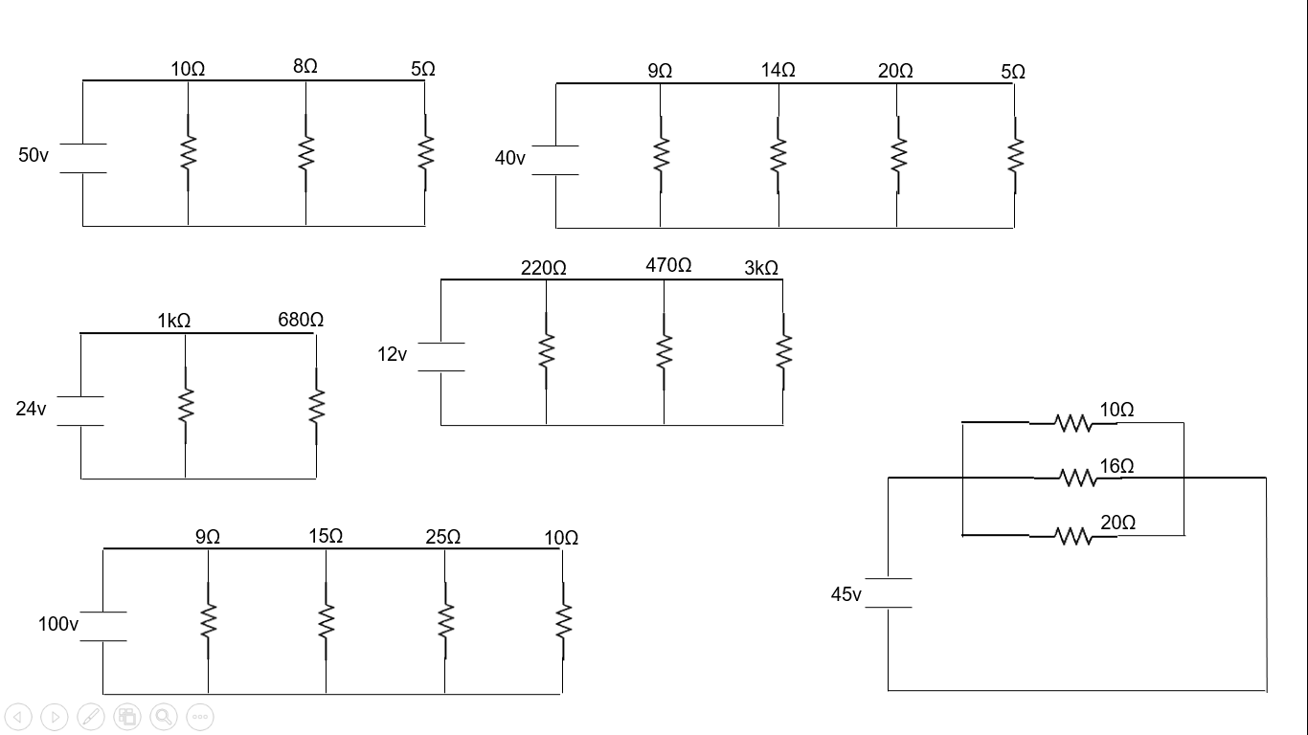

**Rt = 404.76Ω**

3.- Solve the following circuit by finding: Total resistance, Total voltage, Total current, and voltage drop in each of the resistors.

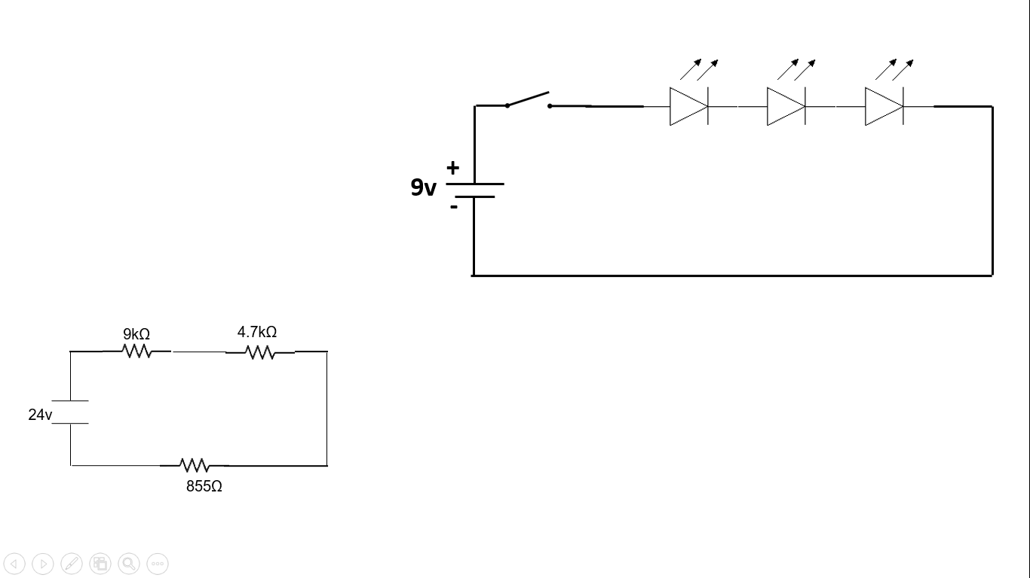

Rt = 9000Ω+4700Ω+855Ω=14555Ω

It = 0.001648A

Vt = 24V

V1 = 14.84V

V2 = 7.74V

V3 = 1.409V

4.- Solve the following circuit by finding: Total resistance, Total voltage, Total intensity, and the Current intensity that runs through each path.



Rt = 142.74Ω

It = 0.084A

Vt = 12V

I1 = 0.0545A

I2 = 0.0255A

I3 = 0.004A